Installing Marlin Firmware on DAMx 3D Printer

This guide will walk you through installing the modified Marlin firmware onto DAMx machine.
1. Download Marlin Firmware
- Download the modified Marlin source code from the provided Google Drive link.
- Extract the file (DamX_19_Mar_2026) to a convenient location on your computer.
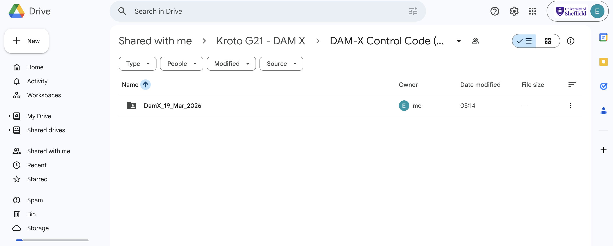
2. Install Visual Studio Code
- Download and install Visual Studio Code (VS Code) from the official website.
- Launch VS Code after installation.
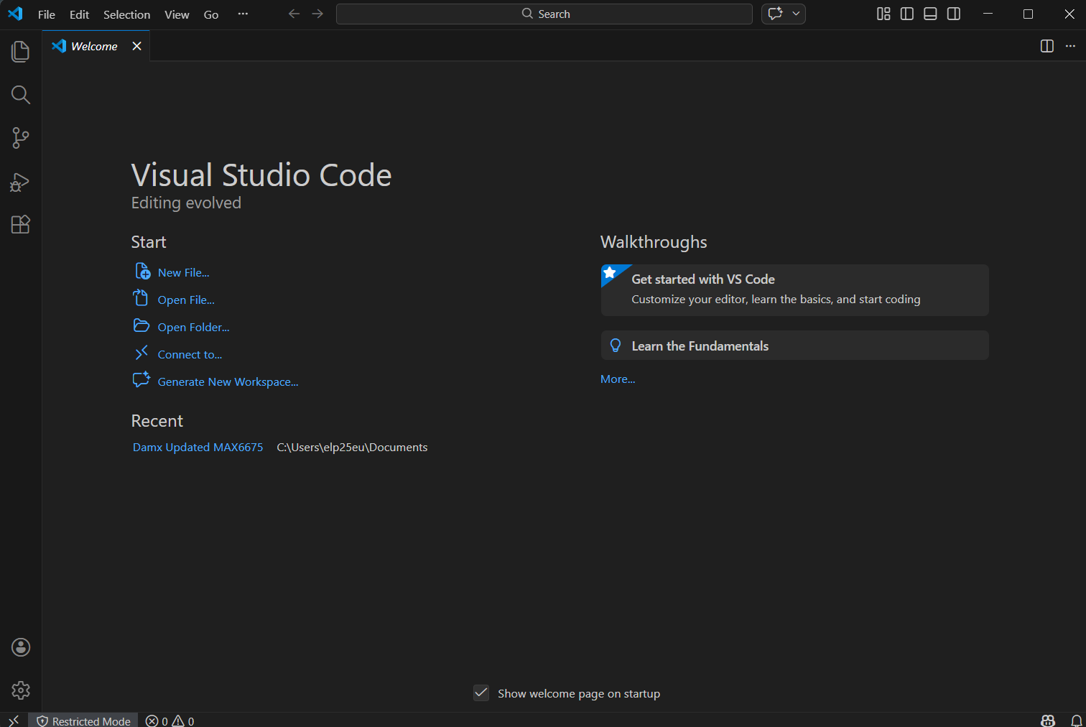
3. Install PlatformIO Extension
- In VS Code, go to the Extensions panel (left sidebar or press Ctrl + Shift + X).
- Search for PlatformIO IDE.
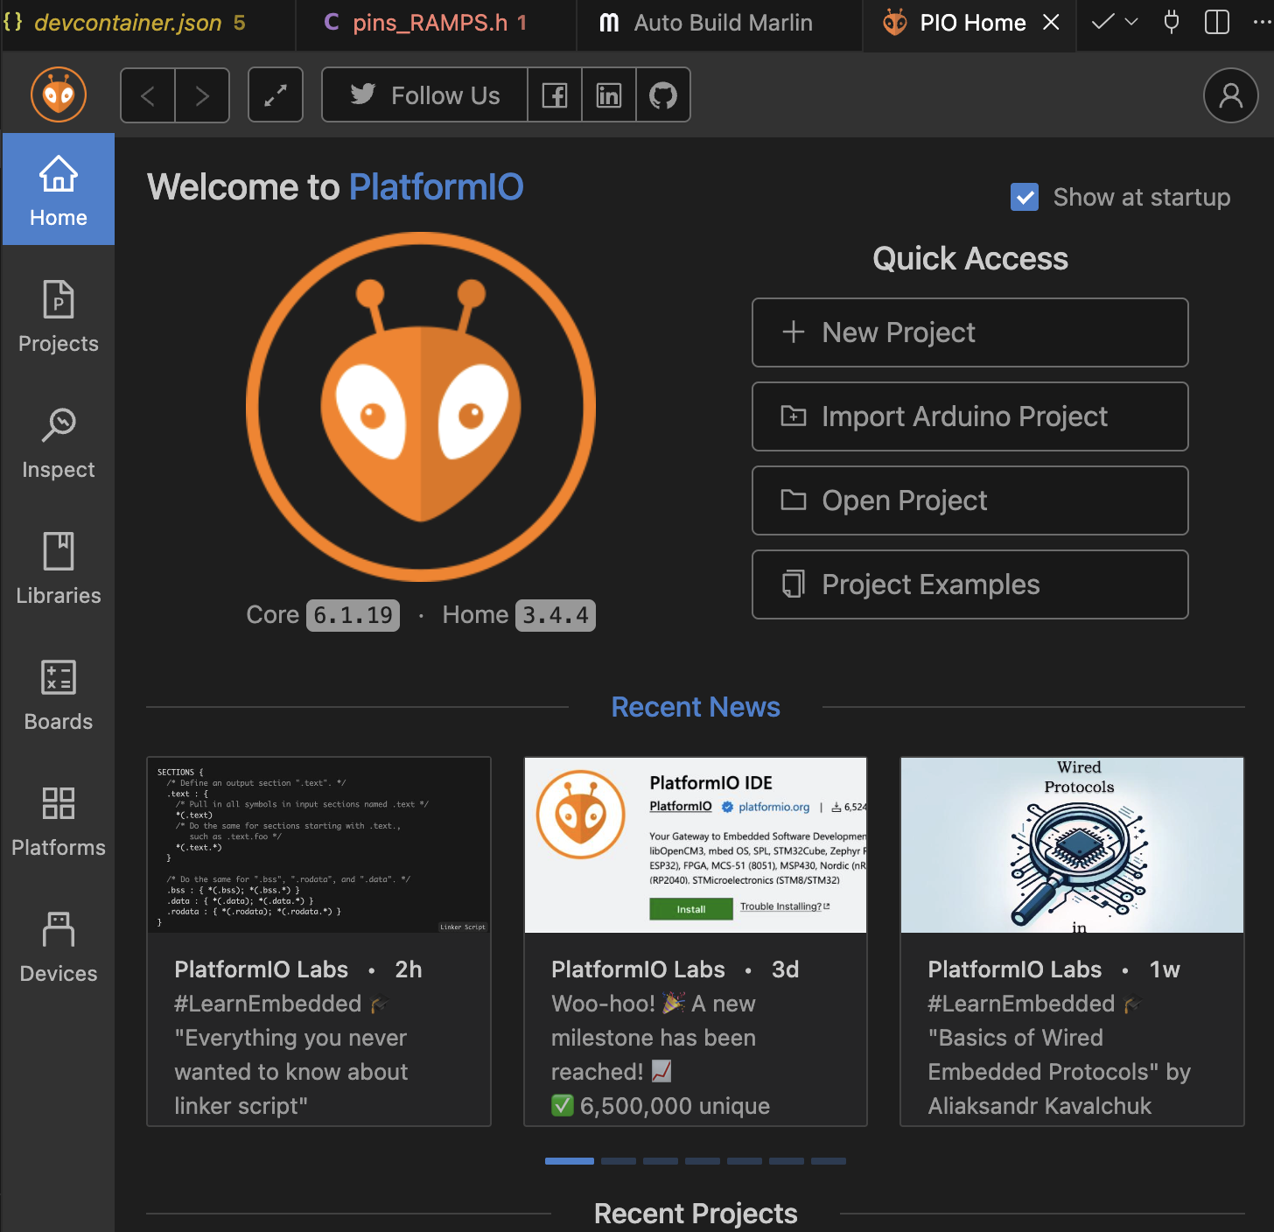
- Click Install.
4. Open the Firmware Project
- In VS Code, click File → Open Folder.
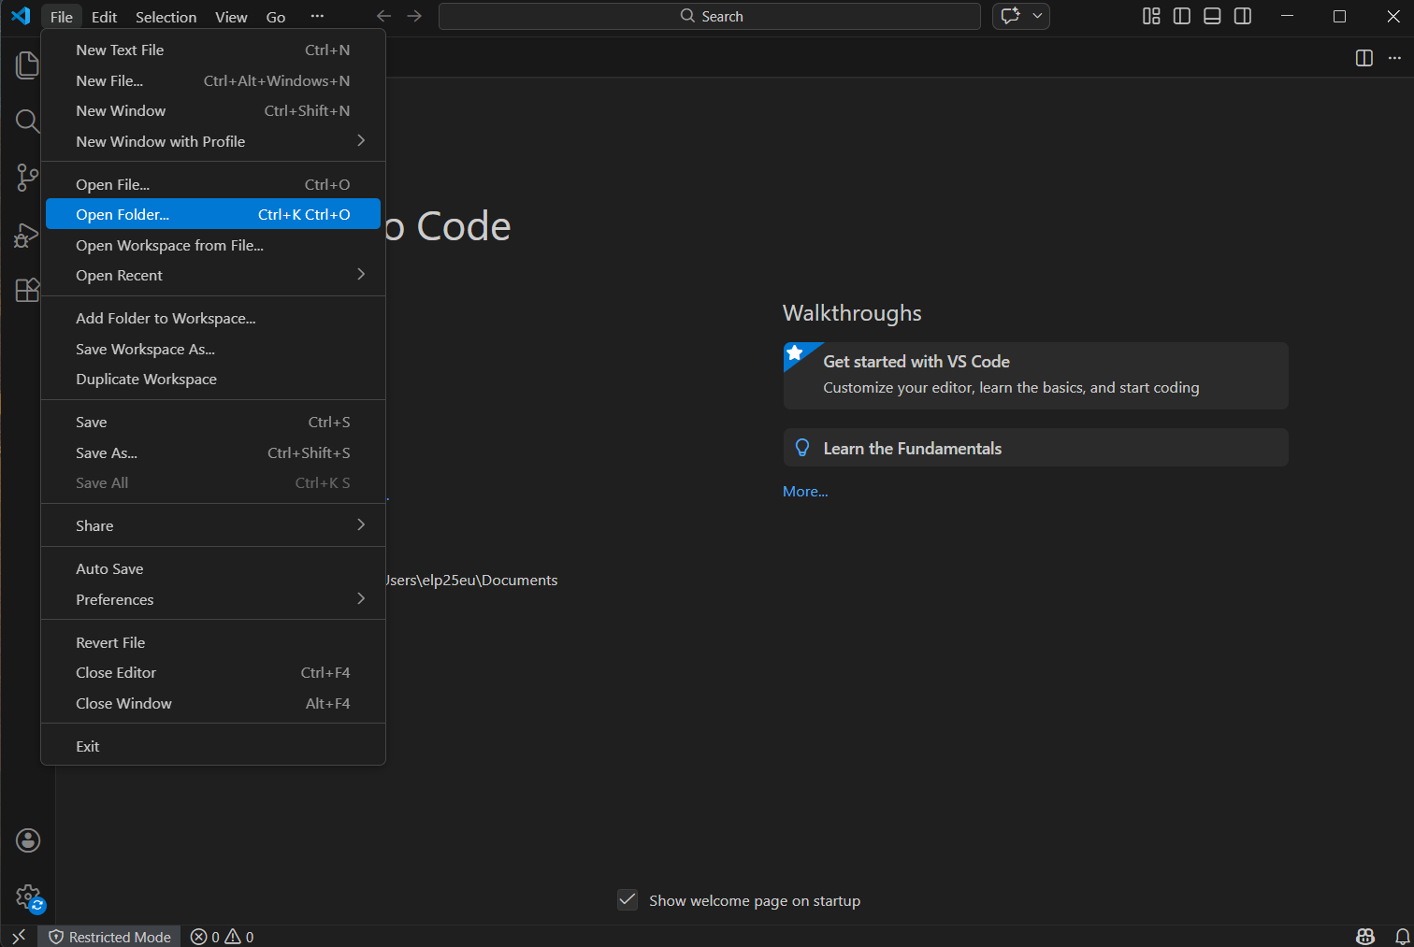

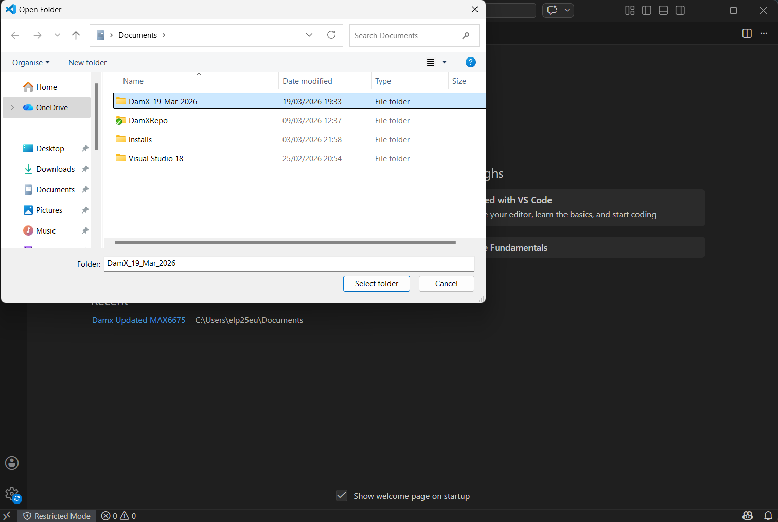

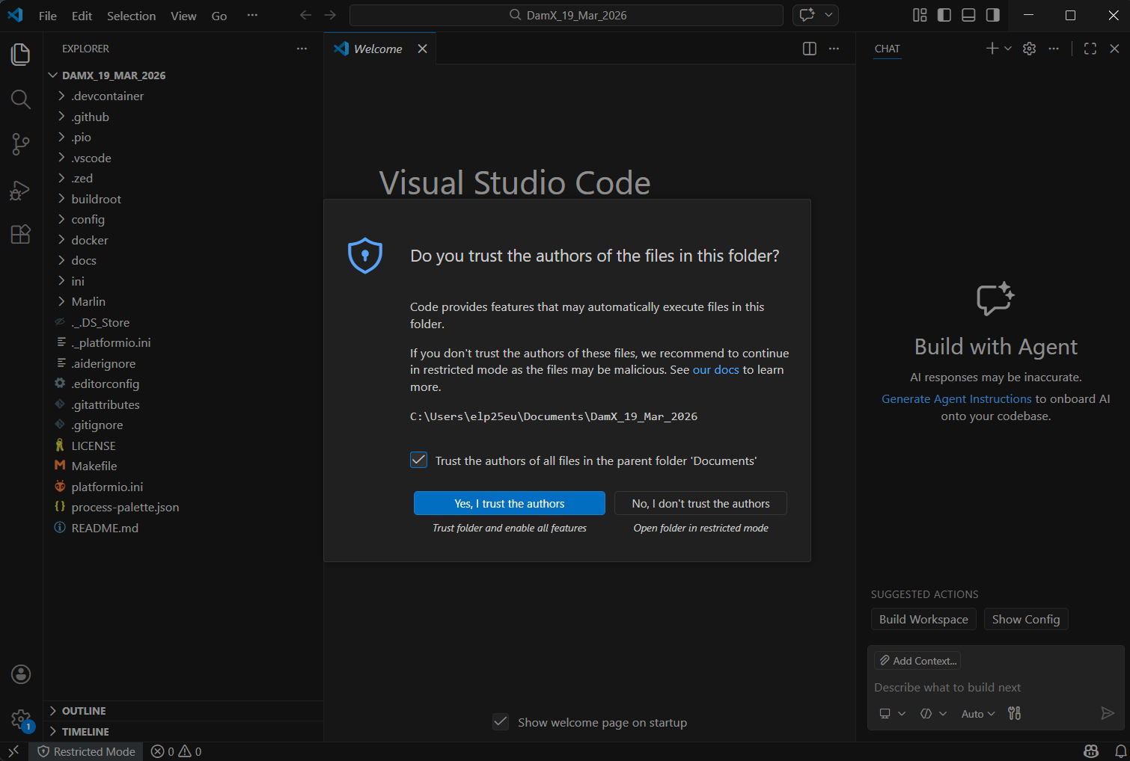

- Select the root folder of the extracted Marlin firmware (the main folder containing platformio.ini).

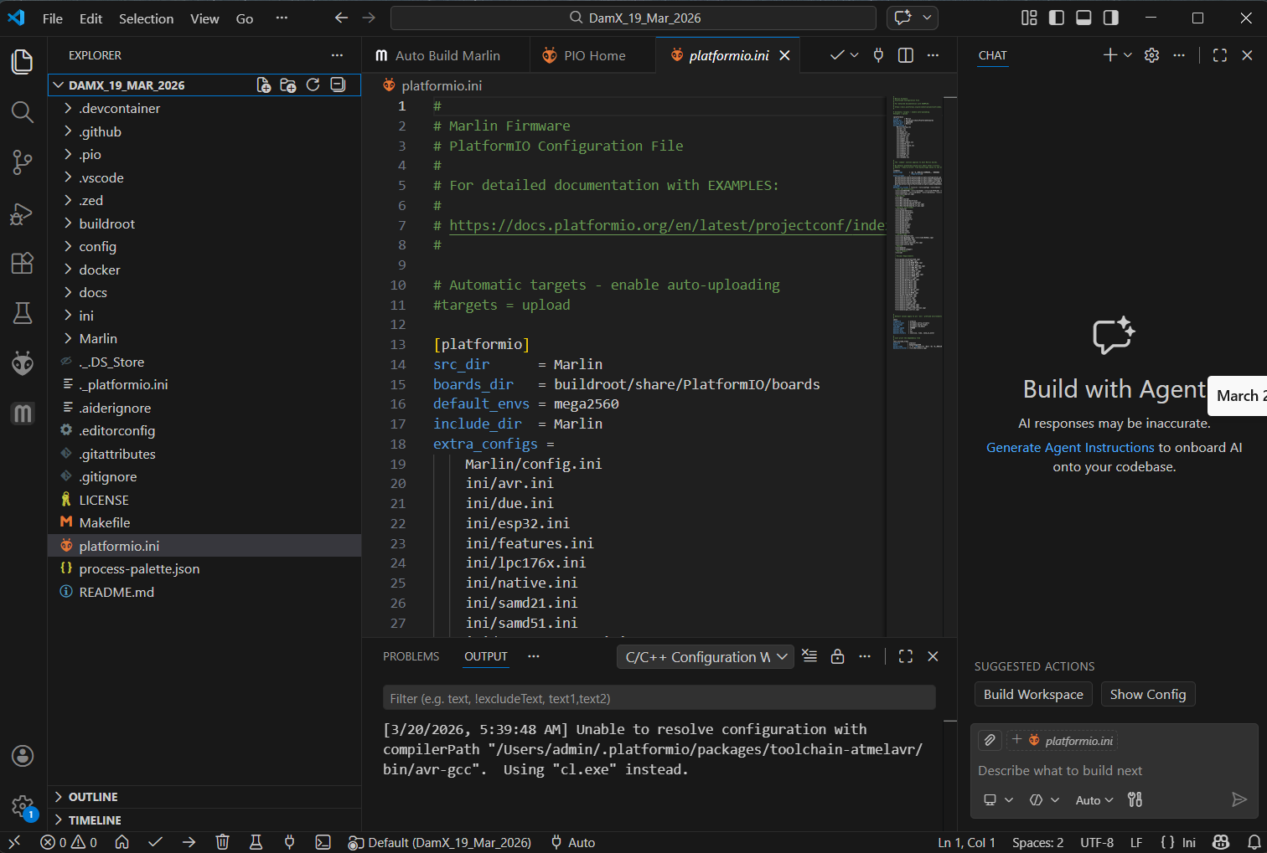

5. Compile the Firmware
- Wait for PlatformIO to initialize the project.
- Click the checkmark (✔) icon in the bottom toolbar to build/compile the firmware.
- Ensure the build completes successfully with no errors.
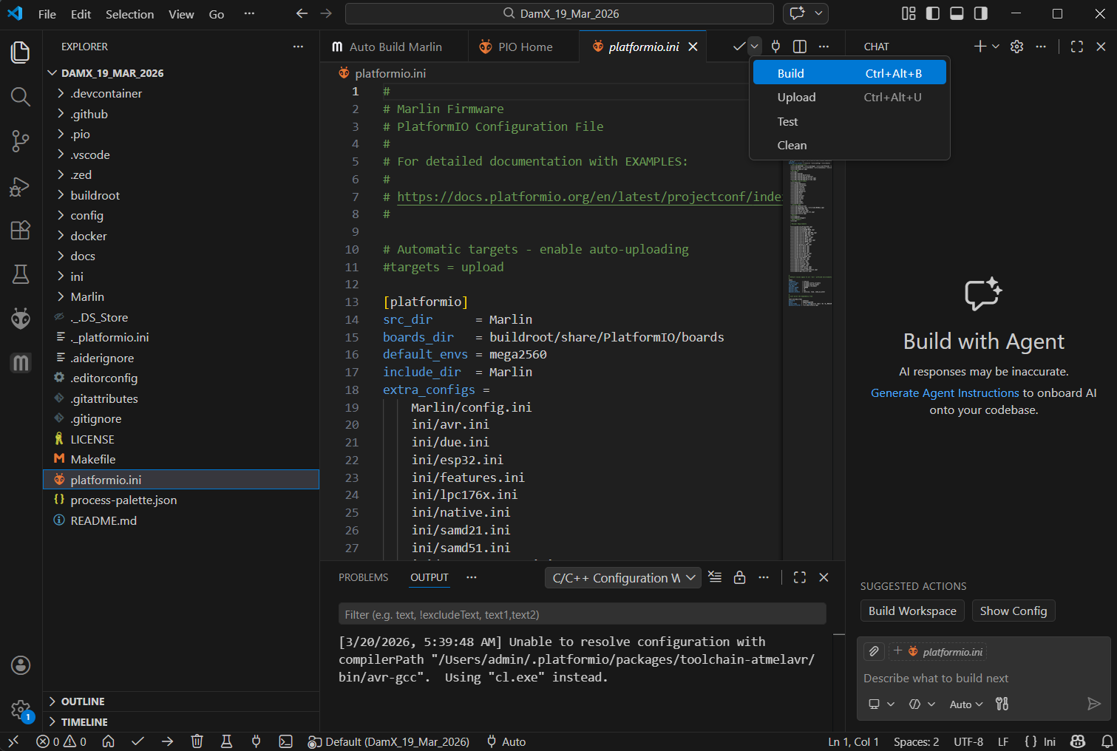

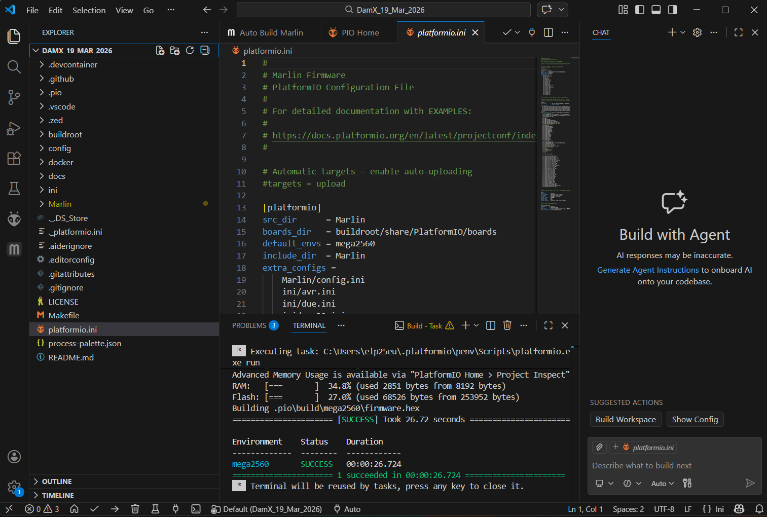

6. Connect the DAMx Printer
- Connect your DAMx 3D printer to your computer using a USB cable.
- Make sure the correct COM/serial port is detected.
7. Upload (Flash) the Firmware
- In VS Code, click the right arrow (→) icon in the bottom toolbar to upload the firmware.
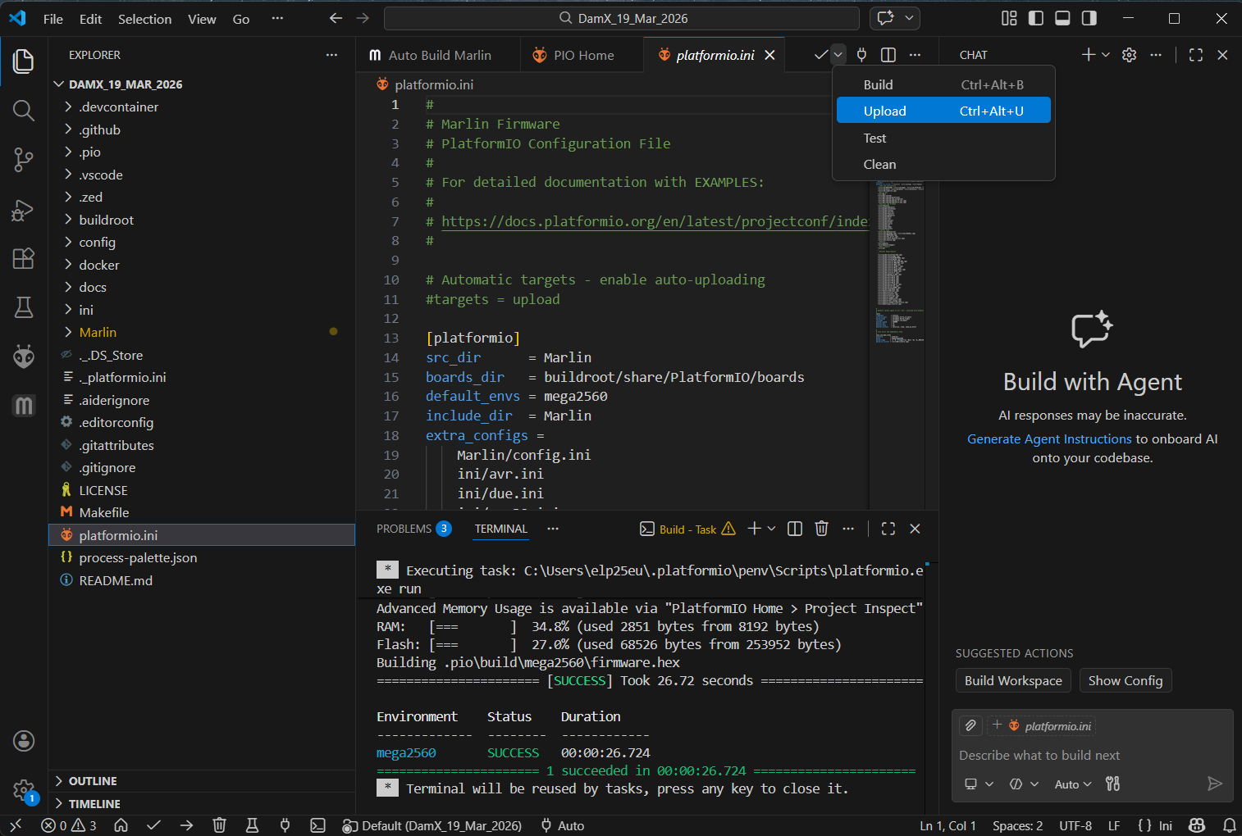
- PlatformIO will compile (if needed) and flash the firmware to the ATmega2560 board.
8. Completion
- Once the upload is successful, the firmware is installed.
- DAMx printer is now ready to use with the updated Marlin firmware.

